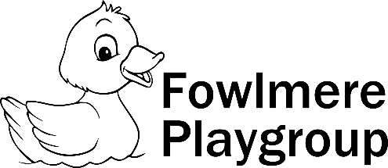
No Smoking Policy

Our Aim:
At Fowlmere Playgroup we comply with health and safety regulations and the Welfare Requirements of the EYFS in making our setting a no-smoking environment - both indoor and outdoor. “Providers have a no-smoking policy, and must prevent smoking in a room, or outside play area, when children are present or about to be present.” This includes parents who may be accompanying children on outings away from Playgroup. This policy also applies to electronic cigarettes / Vapes.
Over 80% of second-hand smoke is invisible and odourless. Children exposed to Second-hand smoke may have an increased risk of respiratory infections and asthma which may result in hospitalisation. We respect that it is a personal choice to smoke, although as an organisation we support healthy lifestyles and therefore help staff and parents to stop smoking. To promote the good health of all, Fowlmere Playgroup is committed in positively supporting staff and families to stop smoking to improve not only their own health but also their children’s.

Procedures:
- All staff, parents and volunteers are made aware of our No-smoking Policy.
- We display no-smoking signs.
- The No-smoking policy is stated in our information for parents.
- We actively encourage no-smoking by having information for parents and staff where to get help to stop smoking if they are seeking this information.
- Staff who smoke do not do so during working hours or whilst wearing their work uniform.
- Providing details of available forms of support such as NHS quit smoking helpline - www.smokefree.nhs.uk
This policy was adopted at the meeting of: …….. Fowlmere Playgroup………
Held on: ………………Nov 2018…………..……
To be reviewed: …………Jan 2023…………………….
Signed on behalf of
Management committee: ……………………………………………....
Name of signatory: ……………K Holwell…(chairperson)…………………
Reviewed/updated Jan 2022 - Verity Smith
Reviewed - No changes Jan 2023 - Verity Smith
Reviewed/updated Jan 2024 - Verity Smith

